**GSC Visitors’ profile**

**2018-2019**

**Key points**

GSC is the “Science Centre for Scotland” as (based on post visit surveys with 2,394 visitors):

74% of visitors come from Scotland; Of the Scottish visitors, over 64% of visitors travelled in from outside of Glasgow and Clyde;

Post visit, 92% of visitors believe they have learned something new from their visit; 85% of visitors find science more interesting following; and 83% want to find out more about science. Considering that most visitors either have general knowledge of science (67.1%) or limited knowledge (5.3%), this is even more impactful.

60% strongly agree and 31% agree that GSC provides high quality educational experience.

The impact of a visit on female visitors is slightly higher with 87% of female visitors wanting to find out more about science following their visit. The fact that over half of GSC’s science communicators are female has been noticed by visitors as good role models.

Feedback from visitors show that GSC’s staff inspire visitors to find out more about science:

“I was amazed by the staff’s specialist knowledge as well as the enthusiasm with which they deliver programmes. They are absolutely a highlight.”

For those who cannot visit GSC because of distance, GSC’s On Tour team reached out to 122,598 people – split 30,149 schools and 92,449 community events. On Tour reached out as far as the Northern Isles of Orkney or Westray.

**Numbers 2018-2019**

397,433 visitors І 322,343 public visitors І 75,090 education

4,300 Science Lates І 88,689 Planetarium shows І 9,463 Glasgow Tower

8,826 Planetarium events І 38,797 science shows І 36, 722 workshops

122,598 Outreach І 30, 149 schools (outreach) І 92,449 community (outreach)

3 Curiosity Live events І 11 days, 50 experts celebrated research and innovation in Scotland

**Impact of a visit**

Based on post visit surveys filled in by 2,394 visitors:

* 92% of visitors believe they have learned something new from their visit;
* 95% of visitors think Science Centres portray science more honestly than the media;
* 85% of visitors find science more interesting following their visit;
* 83% of visitors want to find out more about science following their visit.

As 67% of visitors admit they have general knowledge of science and an additional 6% have limited knowledge the impact is even greater.

“This is such a brilliant attraction for kids and adults that promote education through fun filled activity and give inspiration and aspirations to the youngsters...at least it did for me. (TripAdvisor)”

“It is amazing. The scientific principles are simplified in a very easy and attractive ways. Staff is very cooperative” (Google review)

**Impact on female visitors**

Half of the Science Communicators are female and perceived by visitors as ‘role models’:

“There was a refreshing diversity in the set of people presenting the shows and working the various exhibits. It's good to show that science is for everyone.” (VisitFlow, post visit survey)

* 92% of female visitors said they had learned something new;
* 94% of female visitors think Science Centres portray science more honestly than the media;
* 86% find science more interesting following their visit;
* 87% of female visitors find science more interesting.

**Visitors’ origins**

74% of visitors come from Scotland making Glasgow Science Centre the Science Centre for Scotland:

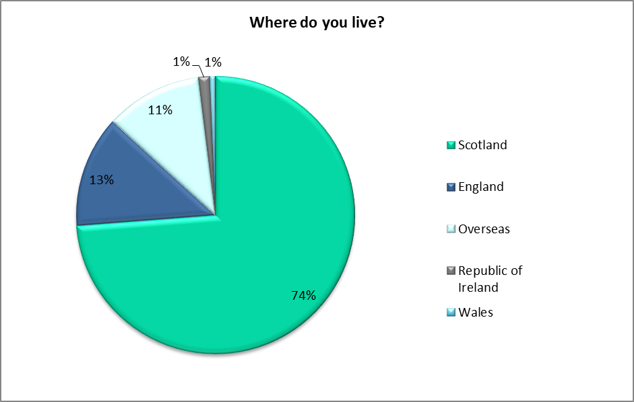

Local visitors only make up 34% of the Scottish visitors. Over 64% travel from further afield, including Lanarkshire (14%), Renfrewshire / Dunbartonshire and Inverclyde (11%) .

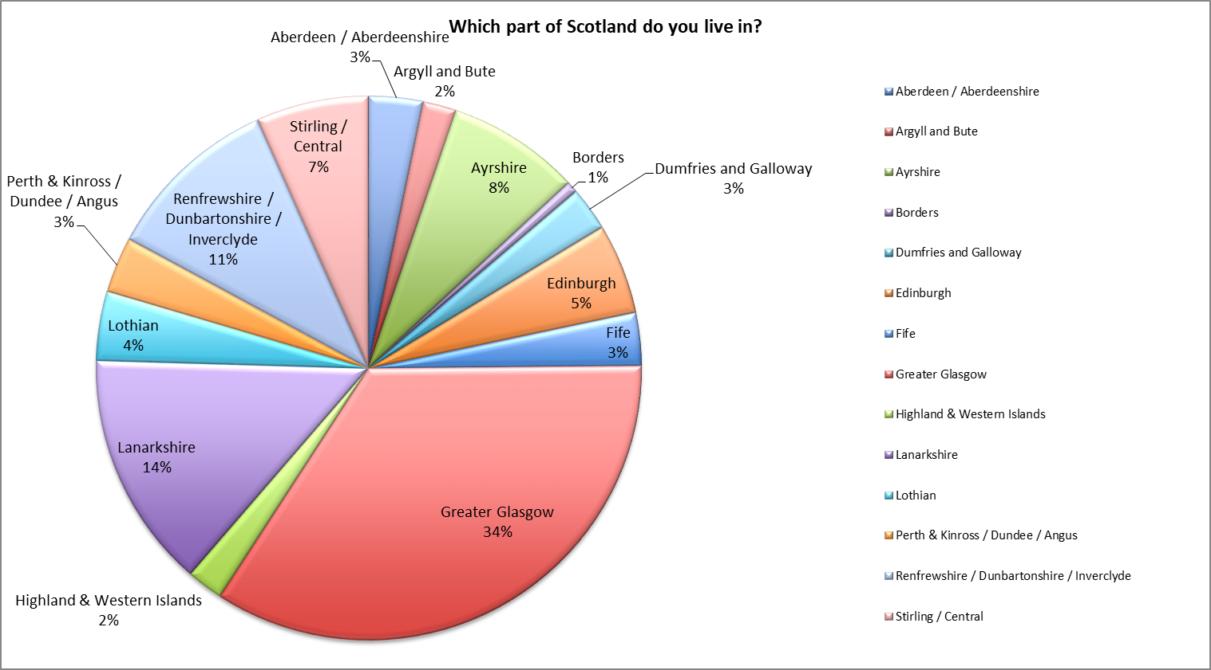

**An increasingly diversified Science Centre**

We have been monitoring how diversified our visitors are focusing on aspects such as disability; ethnic minority and disadvantage. Between June 2018 2018 and June 2019, we note increasingly more diverse groups of visitors.

**Disability**

**June 2018**

6.7% visitors considered they had a disability or long term health condition

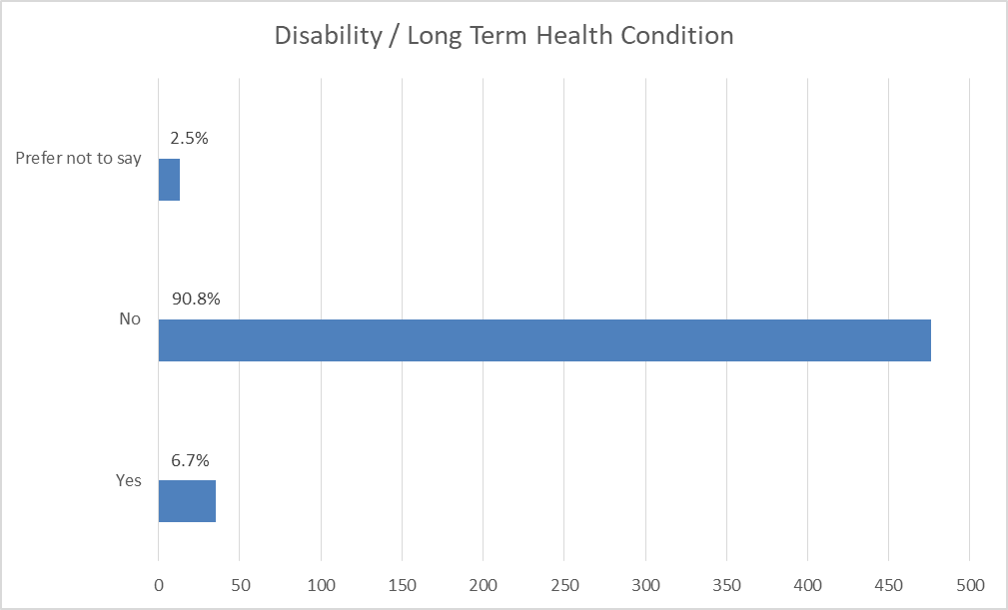

**June 2019**

7.8% visitors considered they had a disability or long term health condition.

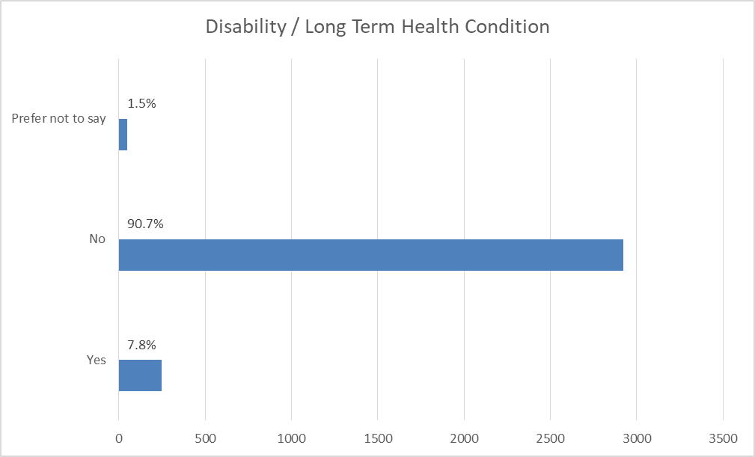

**Ethnic minority**

In June 2018, 10.7% considered themselves from an ethnic group other than white. In June 2019, this has gone up to 14.06%.

**June 2018**

89.3% considered themselves white; 10.7% other than white.

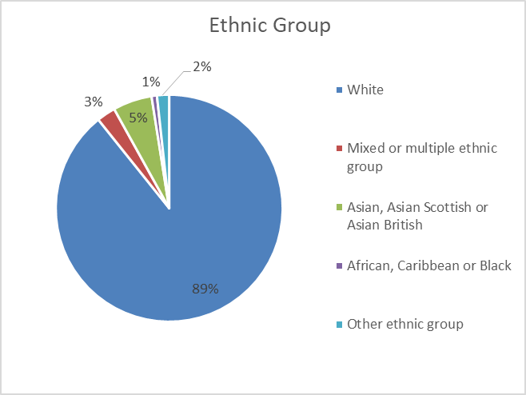

**June 2019**

85.94% considered themselves white; 14.06% other than white.

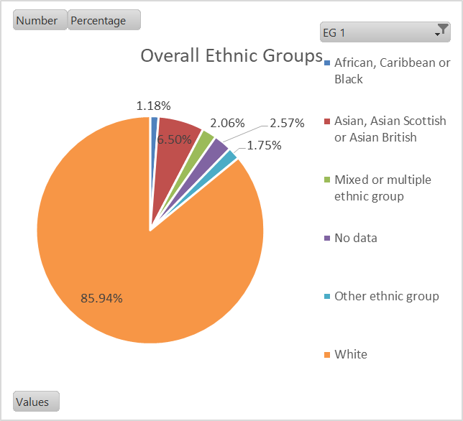

**Deprived areas**

In June 2018, 17.9% of visitors came from deprived areas (SIMD < 20%) as opposed to 19.1% in June 2019 – a small but significant progression.

**June 2018**

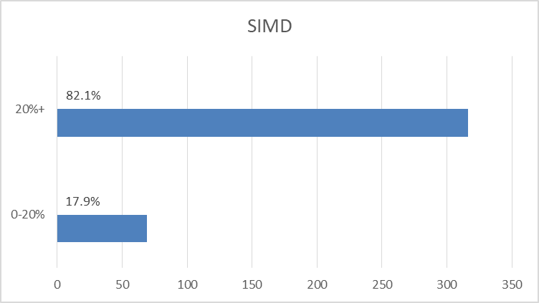

**July 2018**

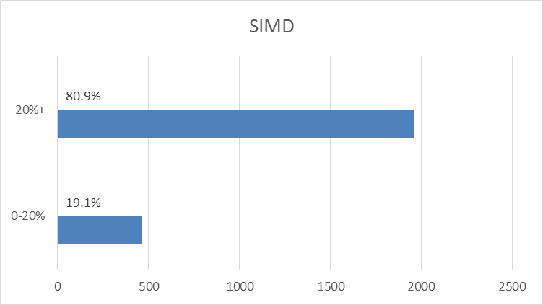

**On Tour**

For those who cannot visit GSC because of distance, GSC’s On Tour team reached out to 122,598 people – split 30,149 schools and 92,449 community events. On Tour reached out as far as the Northern Isles of Orkney or Westray. Please note:

* On the map, yellow is schools, red is family / community;
* we visited 29 out of the 32 local authority areas in Scotland in 2018/19, with the exceptions being Western Isles (visited 2019/20), Shetland (visiting 2020/21), and Angus (a strange black hole that rarely if ever engages with us either in-house or on tour).

